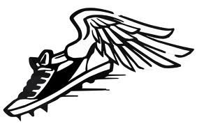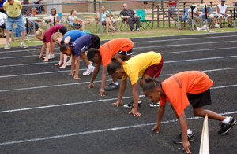

COME OUT AND JOIN OUR TEAM!!!

IT STARTS HERE!

 THE SUPERSONICS TRACK CLUB REGISTRATION IS HERE!

We will be accepting registrations for our 2017 Spring/Summer Season. You may register at the indoor practice site, 40 Van Dyke Ave, New Brunswick , NJ During the following dates: March 21,22,23,28,29,30, 2017. Practices will be held from 6PM-8PM during registration. We will be indoors for practice until April. Ongoing practices and registration for athletes will continue at Memorial Stadium, Joyce Kilmer Ave behind New Brunswick Middle School April 4,5,6, 2017 and every Tuesday, Wednesday, and Thursday thereafter from 6PM-8PM.

SUPERSONICS Track Club

YEAR AROUND TRAINING AVAILABLE

Be a part of Supersonics Track Club successful Track & Field Program. The club has and continues to produce some of New Jersey’s top athletes!

Fall Training: October

Indoor: Nov* ~ Mar

Outdoor: Mar ~ Jul

Outdoor: Mar ~Jul

* We also participate in The Colgate Women’s Games each winter*

#### Connect with us!

#### 

#### Website:  [www.supersonicstrack.com](http://www.supersonicstrack.com/)

#### 

#### Email: Supersonicstc@gmail.com

#### 

#### Phone: 732-354-1708

We want you!